**A PROJECT REPORT ON**

**EVENT MANAGEMENT SYSTEM**

***In partial fulfillment for the award of the degree Of***

**BCA**

**IN**

**C­­­­­OMPUTER SCIENCE DEPARTMENT**

**SEETA DEVI COLLEGE, BHILWARA**



**MDS UNIVERSITY: AJMER**

**SESSION- 2019-20**

**SUBMITTED TO SUBMITTED BY**

**Miss.Diksha Agarwal** **MANSI SHARMA**

**PRIYANSHI BIRLA**

**VARSHA SHARMA**

**PROJECT WORK EVALUATION**

**NAME -**  **MANSI SHARMA**

**PRIYANSHI BIRLA VARSHA SHARMA**

* **PROJECT TITLE - EVENT MANAGEMENT SYSTEM**
* **SOFTWARE BASE - FRONT END - VISUAL STUDIO 2010 ULTIMATE**

**BACK END - MS SQL Server**

|  |  |  |  |  |
| --- | --- | --- | --- | --- |
| **Student Name** | **Enrollment No.** | **Roll No** | **Total Marks** | **Obtain Marks** |
| **Mansi Sharma** | **2017/44802** |  |  |  |
| **Priyanshi Birla** |  |  |  |  |
| **Varsha Sharma** |  |  |  |  |

* **FORWARDING BY HEAD OF COLLEGE**

**………………………………………………………………………………..**

**(SIGNATURE, NAME AND COLLEGE SEAL)**

**……………………….**

**PREFACE**

We have made this report file on the topic EVENT MANAGEMENT SYSTEM. We have tried our best to elucidate all the relevant detail to the topic to be included in the report. While in the beginning we have tried to give a general view about this topic. Our efforts and wholehearted co-corporation of each and everyone has ended on a successful note.

Project fulfills the necessity of a Event Management system in the companies. This project gives idea about what are the things which are to be taken in consideration while handling an event and what sort of challenges are faced by an event manager. This project specifically talks about two events handled by our college during the academic year.

**ACKNOWLEDGEMENT**

We take this opportunity to express our gratitude to all those people who have been directly and indirectly with us during the completion of this project.

We pay a special thanks to Ma’am Miss Diksha Agrawal who given guidance and given a light to us during making a project to her versatile knowledge has eased us in the critical during the span of this project.

We should like to add a sincere note of thanks to the entire member of computer lab in our college for being so co-operative and encouraging all through the project.

Our honest thanks to Principal Sir Dr. S.K.Sharma for providing all possible facilities during the course of this project and arranging suitable schedules while the whole project.

We would like to thank our parents who patiently helped us as we went through our work and helped to modify and eliminate some of the irrelevant or un-necessary stuffs.

Next, We would thank Microsoft for developing such a wonderful tool like MS Word. It helped our work a lot to remain error-free.

Last but clearly not the least, We would thank The Almighty for giving us strength to complete our report on time.

We acknowledge here out dept to those who contributed significantly to one or more steps. We take full responsibility for any remaining sins of omission and commission.

**DECLARATION**

I hereby declare that the project entitled “EVENT MANAGEMENT SYSTEM” submitted for the BCA degree is my original work and the project has not formed the basis for the award of any degree, associate ship, fellowship or any other similar titles.

Signature of the Student:

MANSI SHARMA

PRIYANSHI BIRLA

VARSHA SHARMA

Place:

Date:

**TABLE OF CONTENT**

1. Abstract
2. Introduction

* Project Aim and Objective

1. System Analysis

* Hardware and Software Requirement
* Development Tool and Technology

1. System Design

* Data Flow Diagram(DFD)
* Entity Relationship Diagram(ERD)
* Table Design

1. Coding

* Snapshots with module description
* Snapshots of Database

1. Testing and Implementation
2. User Manual
3. Conclusion

* Limitation of Project
* Future Scope

1. Bibliography
2. Soft Copy of Project

**ABSTRACT**

# Event management, the very topic looks challenging. Irrespective of the type or the scale of the event, the mental and physical hard work that is to be put in, differs by only a negligible degree of difference.

# This terminology is comparatively very new to India, though Indians have been arranging for wedding ceremonies, naming & threading ceremonies even much before independence. But due to the lack of proper forecasting, proper material handling they used to end up in problems like wastage of the food due to less people coming in or fire in the pandal or food poisoning .These problems many a times used to put the families into financial trouble after the wedding.

# INTRODUCTION

# PROJECT AIM AND OBJECTIVE:-

# The Project “EVENT MANAGEMENT SYSTEM” is aimed to developed to maintain the day-to-day state of booking of event ,bill generation, and etc.

# This terminology is comparatively very new to India, though Indians have been arranging for wedding ceremonies, naming & threading ceremonies even much before independence. But due to the lack of proper forecasting, proper material handling they used to end up in problems like wastage of the food due to less people coming in or fire in the pandal or food poisoning .These problems many a times used to put the families into financial trouble after the wedding.

**SYSTEM ANALYSIS**

The success of the developer and implemented system’s highly dependent on the outcome of this phase of the system life cycle. This phase consists of the process of examining the existing system and then pointing out the drawbacks of the existing system along with the merits of the proposed system, just like a detailed comparative study of the system.

Therefore, we can conclude that system analysis is the process of finding the body facts of the problems, the process of diagnosis the problem and in the process recommending the right solution for improving the current system.

Problems with the Existing Event Management System :- The problems of the existing manual system of event working include among others the following:

1. Expensive and Time consuming: The process of collecting data and entering this data into the database takes too much time and is expensive to conduct, for example, time and money is spent in printing data capture forms, in preparing registrations together with human resources, and there after advertising the days set for registration process including sensitizing customers on the need for registration, as well as time spent on entering this data to the database.
2. Too much paper work: The process involves too much paper work and paper storage which is difficult as papers become bulky with the population size.
3. Errors during data entry: Errors are part of all human beings; it is very unlikely for humans to be 100 percent efficient in data entry.
4. Loss of registration forms: Some times, registration forms get lost after being filled in with customer’s details, in most cases these are difficult to follow-up.

HARDWARE REQUIREMENTS

|  |  |
| --- | --- |
| Processor | Intel® Core™ Duo E8500 CPU @ 3.16 GHz |
| Hard Disk | 500 GB |
| RAM | 4.00 GB |
| Display | 15.5’’ Color display |
| Others | Keyboard, Mouse |

# SOFTWARE REQUIREMENTS

|  |  |
| --- | --- |
| Platform | Windows 7 |
| Language(Front End) | Visual Studio 2010 Ultimate |
| Database(Back End) | MSSQL Server |

# 

# DEVELOPMENT TOOL & TECHNOLOGY

**OVERVIEW OF VISUAL STUDIO**

Many of the things that you do with VS really aren’t very basic at all. The VS is quite powerful if you can imagine a programming task; it can be accomplished using VS.

As You might guess, theirs is a to be learned before you can consider yourself a guess; but once understand the basic of VS you will bind that you are productive in no time at all.

The fastest and easiest way to create application for Microsoft windows, whether you are an experienced professional or brand new to windows programming, VS provides you with a complete set of tools to simplify rapid application development.

So what is VS? The “Visual” part refers to method used to create the GUI rather than writing the numerous line of code to describe the appearance and location of interface elements. You simply add prebuilt objective into place on screen. If you have ever used a drawing programmed such as paint, you already have most of the skills necessary to create an effective user interface.

Visual Studio is a suite of programming language and development tools from Microsoft. It is an **Integrated Development Environment(IDE)** developed by Microsoft to develop GUI, console, Web Applications, mobile apps etc. With the help of IDE, you can create managed code as well as native code. It uses the various platforms of Microsoft software development software like Microsoft Silver light, and Windows API etc. Visual Studio IDE is a full-featured development platform for multiple Operating Systems as well as the web and the cloud. It serves as a testing platform as well.

Microsoft Visual Studio is a good compiler for developing Windows Applications. C# and Visual Basic are programming languages designed for creating a variety of applications that run on the .NET Framework. These languages are powerful, type-safe, and object-oriented. They are built on the .NET compiler Platform “Roslyn” which provides rich code analysis APIs and it’s all open source on Git Hub. Beginners can create useful application by learning just a few of the keywords, yet the power of the language allows professional to accomplish anything that can be accomplished using any other windows programming language.

Visual Studio includes a code editor supporting IntelliSense as well as code refactoring. The integrated debugger works both as a source-level debugger and a machine-level debugger.

The most basic edition of Visual Studio, the Community edition, is available free of charge. The slogan of Visual Studio Community edition is “Free, fully-featured IDE for students, open-source and individual developers.”

Data access feature allow you to create DB, front–end application, and scalable server-side components but most popular database format, including Microsoft SQL server and other enterprise level DB.

Active-xtm technologies allow using the functionality provided by other application, such as Microsoft Word, Word Processor, Microsoft Excel Spreadsheet and other window application you can even information server, Visual Basic Source Safe, SNA Server, and more printed documentation provided with the enterprises Edition includes the Visual Studio Enterprises features book plus.

**VISUAL STUDIO EDITIONS**

Visual Studio comes in three flavors:

* The Visual Studio Community Edition
* The Visual Studio Professional Edition
* The Visual Studio Enterprise Edition
* **The Visual Studio Community Edition**it is the introductory edition that let us easily create Windows application. It comes with all the tools we need to build mainstream Windows applications. It is a free version while all other editions are paid.
* **The Visual Studio Professional Edition**It is for computer professionals and includes advanced feature such as tools to develop ActiveX and Internet controls.
* **The Visual Studio Enterprise Edition**it is the most advanced edition and is aimed at programmers who build distributed applications in a team environment. It includes all the features of the Professional edition, plus tools such as Visual SourceSafe (a version control system) and the Automation and Component Manager.

**MICROSOFT SQL SERVER**

Microsoft SQL Server is the default database of Microsoft Visual Studio 2010. Microsoft SQL Server 2005 provides many new features that make working with data and designing a database even easier. Microsoft SQL Server is a collection of data and objects related to particular topic or purpose. As a database server ,it is a software product with the primary function of storing and retrieving data as requested by other s/w applications.

Microsoft SQL Server is a Relational Database Management System developed by Microsoft. In basic terms, MS SQL Database is capable of storing any type of data that you want. Using SQL Database, we can organize our data according to subject and can store information about how different subject are related. In general MS-SQL database can have several small tables.

Microsoft SQL is the database of choice for Web Applications on a Windows Platform (using .NET or ASP). These languages make it extremely easy to connect to a MS SQL Database. It is also used for many popular content management and other scripts.

Microsoft SQL Server Express is a version of Microsoft’s SQL Server relational database management system that is free to download, distribute and use. It comprises a database specifically targeted for embedded and smaller scale applications. It supports a wide variety of transaction processing , business intelligence and analytics applications in corporate IT environments. Microsoft SQL Server is one of the three market-leading database technologies, along with Oracle Database and IBM’s DB2.

Like other RDBMS technologies, SQL Server is primarily built around a row-based table structure that connects related data elements in different tables to one another , avoiding the need to redundantly store data in multiple places within a database. The relational model also provides referential integrity and other integrity constraints to maintain data accuracy .

System.Data.SqlClient provides access to versions of SQL Server, which encapsulates database-specific protocols. The functionality of the data provider is designed to be similar to that of .NET Framework data providers for OLE DB, ODBC and Oracle. The core component of MS SQL Server is the SQL Server Database Engine, which controls data storage, processing and security. It includes a relational engine that processes commands and queries and a storage engine that manages database files, tables, pages, indexes, data buffers and transactions.

Some professional application developers use SQL Server for rapid application development, especially for the creation of prototypes and standalone applications that serve as tools for on-the-road salesmen. SQL Server does not scale well if data access is via a network, so applications that are used by more than a handful of people tend to rely on Client-Server based solutions. However, SQL Server Access "front end" (the forms, reports, queries and C# code) can be used against a host of database back ends, including JIT (file-based database engine, used in SQL Server by default),Microsoft OLEDB Server, Oracle, and any other ODBC-compliant product.

**Features**

One of the benefits of SQL Server from a programmer's perspective is —queries may be viewed and edited easily , and SQL statements can be used directly in Macros and Modules to manipulate DB tables.

MSDE (Microsoft SQL Server Desktop Engine) 2000, a mini-version of MS SQL Server 2000, is included with the developer edition of Office XP and may be used with SQL Server as an alternative to the Jet Database Engine.

Like the RDBMS software, Microsoft SQL Server is built on the top of SQL, a standardized programming language that database administrators (DBAs) and other IT professionals use to manage databases and query the data they contain. SQL Server is tied to Transact-SQL (T-SQL), an implementation of SQL from Microsoft that adds a set of proprietary programming extensions to the standard language. The core component of Microsoft SQL Server is the SQL Server Database Engine, which controls data storage, processing and security. It includes a relational engine that processes commands and queries and a storage engine that manages database files, transactions etc. Stored procedures, triggers, views and other database objects are also created and executed by the Database Engine.

Sitting beneath the Database Engine is the SQL Server Operating System, or SQLOS. SQLOS handles lower-level functions, such as memory and I/O management, job scheduling and locking of data to avoid conflicting updates. A network interface layer sits above the Database Engine and uses Microsoft’s Tabular Data Stream protocol to facilitate request and response interactions with database servers. And at the user level, SQL Server DBAs and developers write T-SQL statements to build and modify database structures, manipulate data, implement security protections and back up databases, among other tasks.

**SYSTEM DESIGN**

**System Design-**

The main work prior to coding for the proposed system is to sketch the way and tools which are required to develop the proposed system. The main work of the system analyst after analyzing the system is to design the data structure and data flow diagram for coding the proposed system.

**Design Objective-**

The following goes were kept in mind at the time of design the new system-

* To make the system User Friendly which assist no programmer in using the system effectively and efficiently.
* To make the system such an efficient and effective that at the time of interfacing with GUI takes very little time.
* To make the system reliable, understandable and cost effective.
* To make easy processing for storing, updating and retrieve the information of customer for further use.

# DATA FLOW DIAGRAMS (DFD)

**WELCOME**

View Customer

Add Customer

Add Event

Update Event

View Event

Bill Report

**EVENT**

**SCHEDULE**

Update Customer

**LOGIN**

**BOOK EVENT**

**CUSTOMER**

**HOME PAGE**

**ENTITY-RELATIONSHIP DIAGRAM**

Customer

Event

Booking

Customer Books Event

Event Booked

**DATABASE DESIGN**

Database design is the process of producing a detailed data model of a database. This logical data model contains all the needed logical and physical design choices and physical storage parameters needed to generate a design in a Data Definition Language, which can then be used to create a database. A fully attributed data model contains detailed attributes for each entity.

**CUSTOMER TABLE:-**

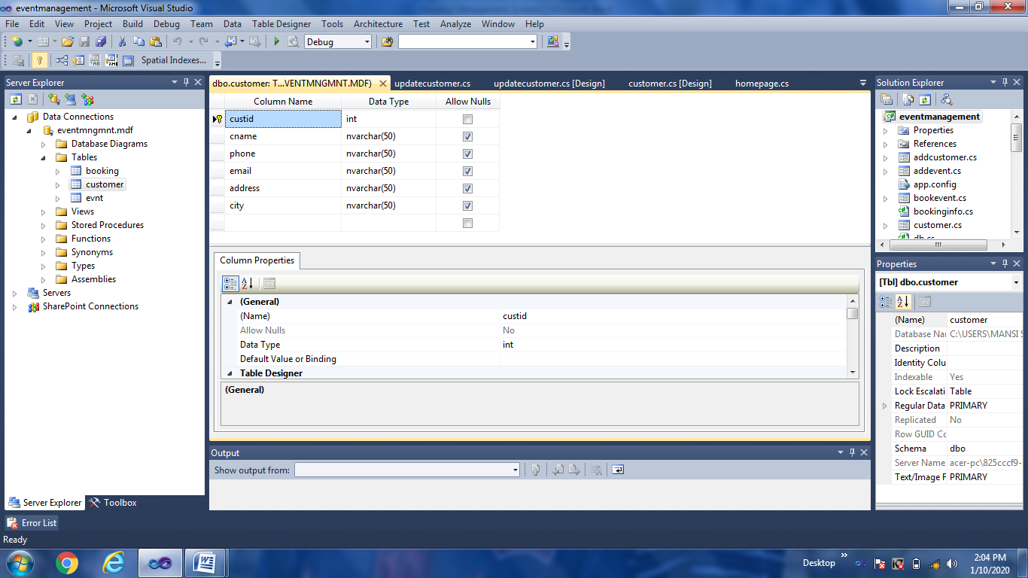

**EVENT TABLE:-**

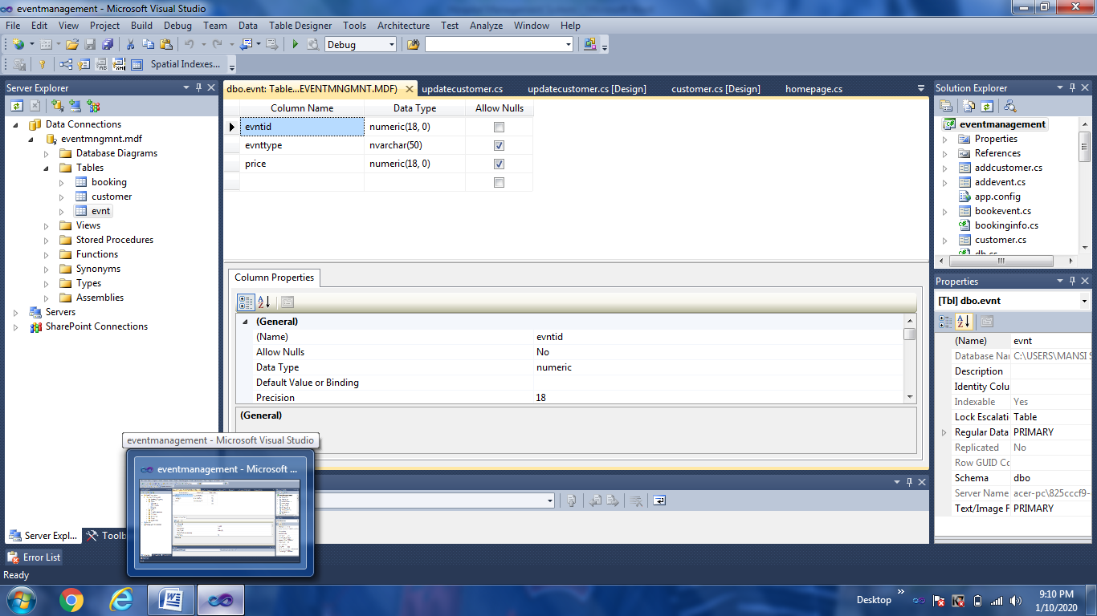

**BOOKING TABLE:-**

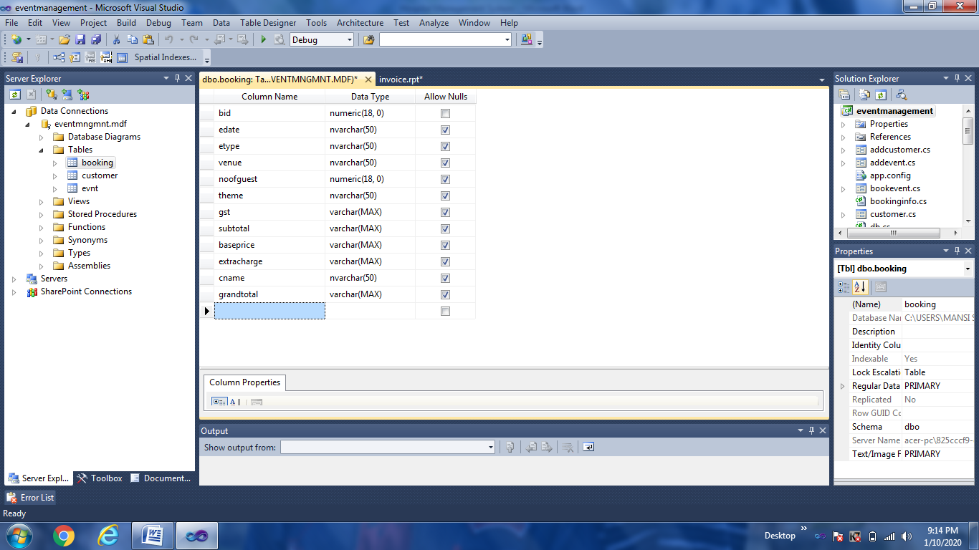

**SNAPSHOTS WITH MODULE DESCRIPTION**

**WELCOME FORM:-**

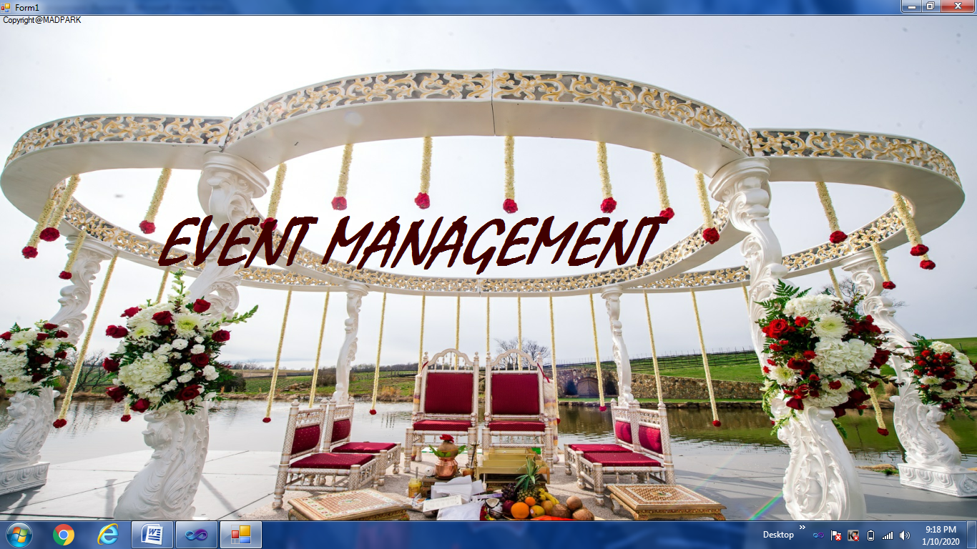

This welcome form is the first screen that will be opened after the application has been started.

**CODING**

using System;

using System.Collections.Generic;

using System.ComponentModel;

using System.Data;

using System.Drawing;

using System.Linq;

using System.Text;

using System.Windows.Forms;

namespace eventmanagement

{

public partial class wlcome : Form

{

public wlcome()

{

InitializeComponent();

}

private void timer1_Tick(object sender, EventArgs e)

{

timer1.Stop();

login f = new login();

f.Show();

this.Hide();

}

private void wlcome_Load(object sender, EventArgs e)

{

timer1.Enabled = true;

timer1.Start();

}

}

}

**LOGIN FORM :-**

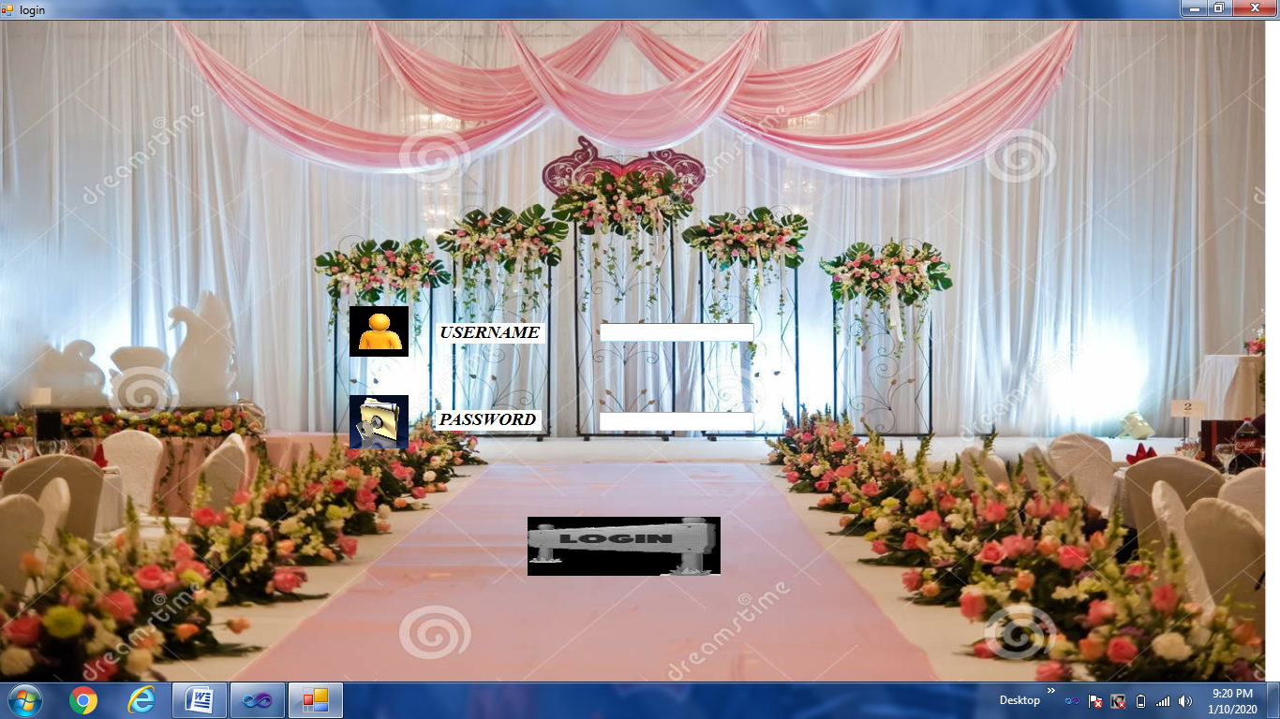

This login form accept username and password. If both are correct then it jumps to Home page.

**CODING**

using System;

using System.Collections.Generic;

using System.ComponentModel;

using System.Data;

using System.Drawing;

using System.Linq;

using System.Text;

using System.Windows.Forms;

namespace eventmanagement

{

public partial class login : Form

{

public login()

{

InitializeComponent();

}

private void pictureBox4_Click(object sender, EventArgs e)

{

if (txtuser.Text == "madpark" && txtpass.Text == "priyanshi")

{

this.Hide();

homepage f = new homepage();

f.Show();

}

else if (txtuser.Text == " " || txtpass.Text == " ")

{

MessageBox.Show("please fill all the details");

}

else

{

MessageBox.Show("incorrect username or password");

}

}

}

}

**HOME PAGE FORM :-**

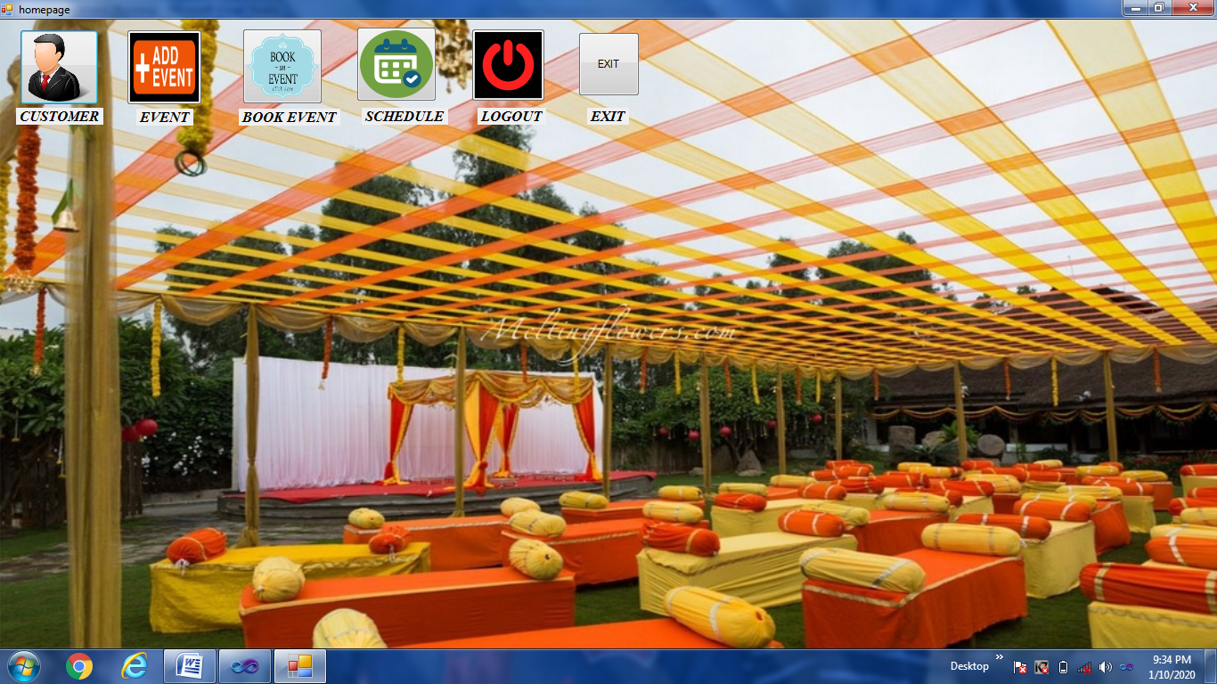

This form provides menu bar with some menu such as change password,utilities,about us etc and some other options as well.

**CODING**

using System;

using System.Collections.Generic;

using System.ComponentModel;

using System.Data;

using System.Drawing;

using System.Linq;

using System.Text;

using System.Windows.Forms;

namespace eventmanagement

{

public partial class homepage : Form

{

public homepage()

{

InitializeComponent();

}

private void button1_Click(object sender, EventArgs e)

{

customer c = new customer();

this.Hide();

c.Show();

}

private void label1_Click(object sender, EventArgs e)

{

customer c = new customer();

this.Hide();

c.Show();

}

private void button2_Click(object sender, EventArgs e)

{

evntt ev = new evntt();

ev.Show();

this.Hide();

}

private void button3_Click(object sender, EventArgs e)

{

bookevent b = new bookevent();

this.Hide();

b.Show();

}

private void label6_Click(object sender, EventArgs e)

{

bookevent b = new bookevent();

this.Hide();

b.Show();

}

private void button4_Click(object sender, EventArgs e)

{

schedule s = new schedule();

s.Show();

}

private void label5_Click(object sender, EventArgs e)

{

schedule s = new schedule();

s.Show();

}

private void button6_Click(object sender, EventArgs e)

{

login l = new login();

this.Hide();

l.Show();

}

private void label3_Click(object sender, EventArgs e)

{

login l = new login();

this.Hide();

l.Show();

}

private void label7_Click(object sender, EventArgs e)

{

evntt ev = new evntt();

ev.Show();

this.Hide();

}

private void button7_Click(object sender, EventArgs e)

{

Application.Exit();

}

private void label2_Click(object sender, EventArgs e)

{

Application.Exit();

}

}

}

**CUSTOMER FORM:-**

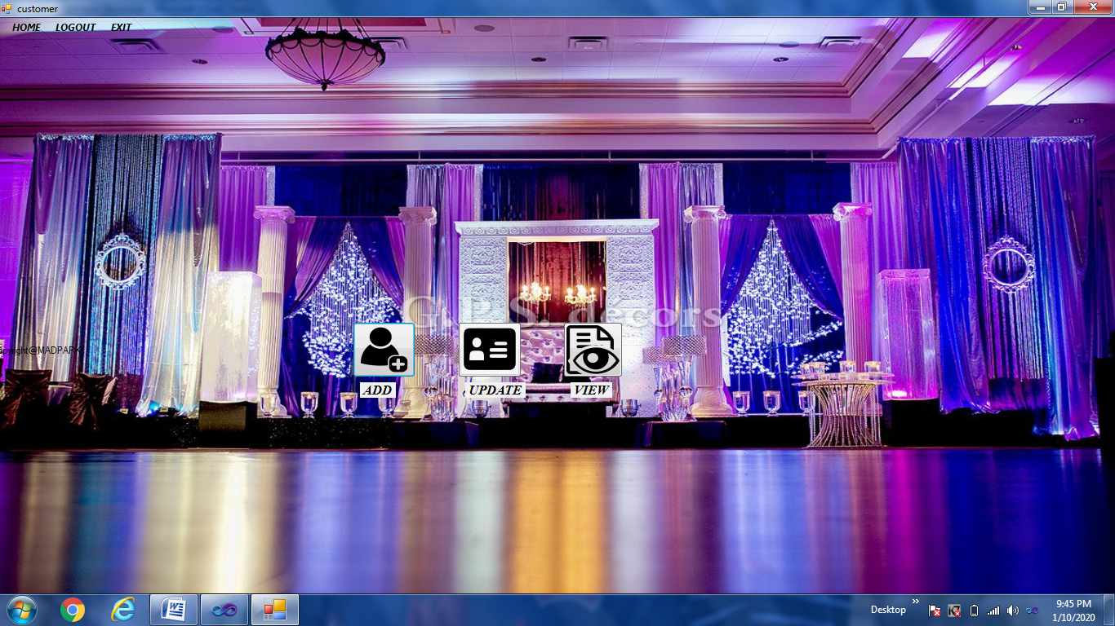

This form provides facility for registering customers by taking their personal, basic and contact details, updating customer details and viewing all customer’s details at once.

**CODING**

using System;

using System.Collections.Generic;

using System.ComponentModel;

using System.Data;

using System.Drawing;

using System.Linq;

using System.Text;

using System.Windows.Forms;

namespace eventmanagement

{

public partial class customer : Form

{

public customer()

{

InitializeComponent();

}

private void button1_Click(object sender, EventArgs e)

{

addcustomer a = new addcustomer();

this.Hide();

a.Show();

}

private void label1_Click(object sender, EventArgs e)

{

addcustomer a = new addcustomer();

this.Hide();

a.Show();

}

private void button2_Click(object sender, EventArgs e)

{

updatecustomer u = new updatecustomer();

this.Hide();

u.Show();

}

private void label2_Click(object sender, EventArgs e)

{

updatecustomer u = new updatecustomer();

this.Hide();

u.Show();

}

private void button3_Click(object sender, EventArgs e)

{

viewcustomer v = new viewcustomer();

this.Hide();

v.Show();

}

private void label3_Click(object sender, EventArgs e)

{

viewcustomer v = new viewcustomer();

this.Hide();

v.Show();

}

private void lOGOUTToolStripMenuItem_Click(object sender, EventArgs e)

{

login l = new login();

this.Hide();

l.Show();

}

private void hOMEToolStripMenuItem_Click(object sender, EventArgs e)

{

homepage h = new homepage();

this.Hide();

h.Show();

}

private void eXITToolStripMenuItem_Click(object sender, EventArgs e)

{

Application.Exit();

}

}

}

**CUSTOMER REGISTRATION FORM:-**

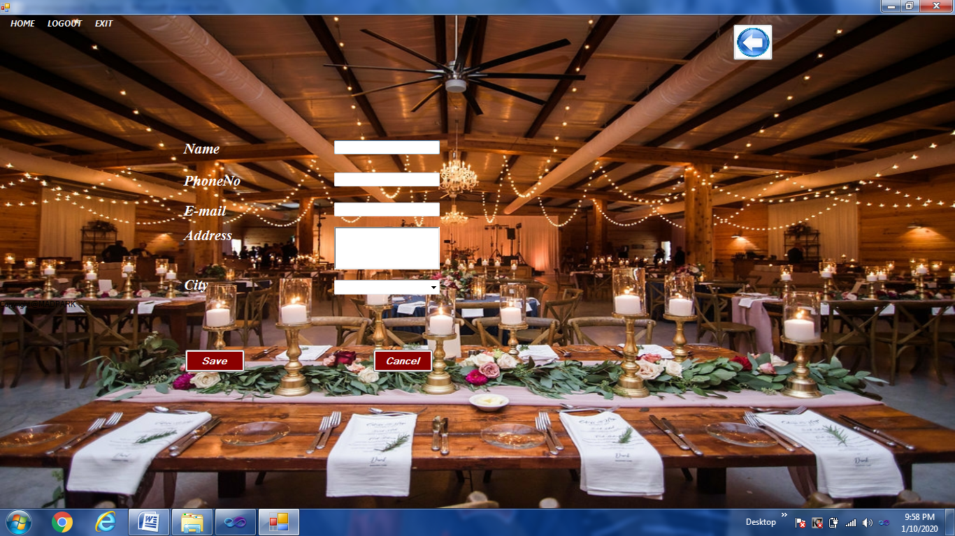

This form to register new customer and all his personal details.

**CODING**

using System;

using System.Collections.Generic;

using System.ComponentModel;

using System.Data;

using System.Drawing;

using System.Linq;

using System.Text;

using System.Windows.Forms;

using System.Data.SqlClient;

namespace eventmanagement

{

public partial class addcustomer : Form

{

SqlConnection con = new SqlConnection(@"Data Source=.\SQLEXPRESS;AttachDbFilename=C:\event management\eventmanagement\eventmanagement\eventmngmnt.mdf;Integrated Security=True;User Instance=True");

SqlCommand com;

int i;

public addcustomer()

{

InitializeComponent();

}

public void clear_data()

{

textBox2.Clear();

textBox3.Clear();

textBox4.Clear();

richTextBox1.Clear();

comboBox1.Text = "";

textBox2.Focus();

}

private void addcustomer_Load(object sender, EventArgs e)

{

if (con.State == ConnectionState.Closed)

{

con.Open();

}

}

private void button1_Click(object sender, EventArgs e)

{

try

{

if ( textBox2.Text == "" || textBox3.Text == "" || textBox4.Text == "" || richTextBox1.Text == "" || comboBox1.Text == "")

{

MessageBox.Show("Please fill all the details");

textBox2.Focus();

}

else

{

string sql = "insert into customer(cname,phone,email,address,city) values(@cname,@phone,@email,@address,@city)";

com = new SqlCommand(sql, con);

com.CommandType = CommandType.Text;

com.CommandText = sql;

com.Parameters.AddWithValue("@cname", textBox2.Text);

com.Parameters.AddWithValue("@phone", textBox3.Text);

com.Parameters.AddWithValue("@email", textBox4.Text);

com.Parameters.AddWithValue("@address", richTextBox1.Text);

com.Parameters.AddWithValue("@city", comboBox1.Text);

com.ExecuteNonQuery();

MessageBox.Show("customer registered successfully");

clear_data();

}

}

catch (Exception)

{

MessageBox.Show("error in registration");

}

}

private void lOGOUTToolStripMenuItem_Click(object sender, EventArgs e)

{

login l = new login();

this.Hide();

l.Show();

}

private void hOMEToolStripMenuItem_Click(object sender, EventArgs e)

{

homepage h = new homepage();

this.Hide();

h.Show();

}

private void eXITToolStripMenuItem_Click(object sender, EventArgs e)

{

Application.Exit();

}

private void button2_Click(object sender, EventArgs e)

{

clear_data();

this.Close();

}

private void textBox3_KeyPress(object sender, KeyPressEventArgs e)

{

if ((e.KeyChar < 48 || e.KeyChar > 57) && e.KeyChar != 8)

{

e.Handled = true;

}

}

private void button3_Click(object sender, EventArgs e)

{

customer c = new customer();

c.Show();

this.Hide();

}

}

}

**CUSTOMER DETAILS UPDATION FORM:-**

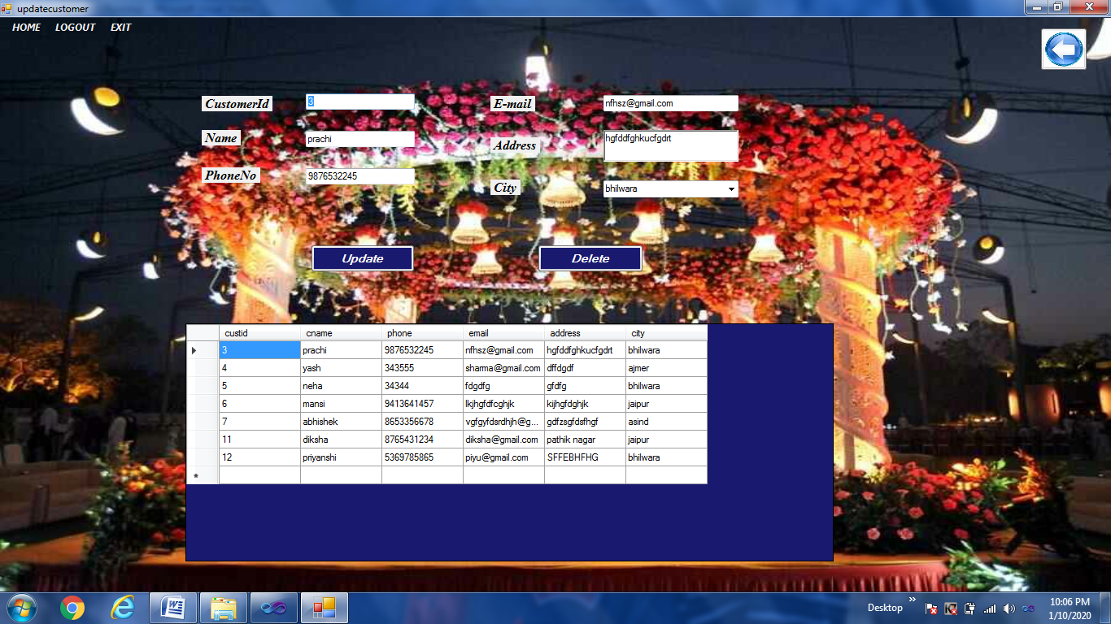

This form to update or delete the information of any customer.

**CODING**

using System;

using System.Collections.Generic;

using System.ComponentModel;

using System.Data;

using System.Drawing;

using System.Linq;

using System.Text;

using System.Windows.Forms;

using System.Data.SqlClient;

namespace eventmanagement

{

public partial class updatecustomer : Form

{

SqlConnection con = new SqlConnection(@"Data Source=.\SQLEXPRESS;AttachDbFilename=C:\event management\eventmanagement\eventmanagement\eventmngmnt.mdf;Integrated Security=True;User Instance=True");

SqlCommand com;

public updatecustomer()

{

InitializeComponent();

}

public void display()

{

if (con.State == ConnectionState.Closed)

{

con.Open();

}

com = con.CreateCommand();

com.CommandType = CommandType.Text;

com.CommandText = "Select * from customer";

com.ExecuteNonQuery();

DataTable dt = new DataTable();

SqlDataAdapter da = new SqlDataAdapter(com);

da.Fill(dt);

dataGridView1.DataSource = dt;

}

public void clear_data()

{

textBox1.Clear();

textBox2.Clear();

textBox3.Clear();

textBox4.Clear();

richTextBox1.Clear();

comboBox1.Text = "";

}

private void updatecustomer_Load(object sender, EventArgs e)

{

this.customerTableAdapter.Fill(this.eventmngmntDataSet1.customer);

display();

}

private void button2_Click(object sender, EventArgs e)

{

int i=Convert.ToInt16(textBox1.Text);

string sql = "delete from customer where custid=" + i ;

try

{

if (con.State == ConnectionState.Closed)

{

con.Open();

}

com = new SqlCommand(sql, con);

com.ExecuteNonQuery();

MessageBox.Show("DATA DELETED SUCCESSFULLY");

clear_data();

display();

}

catch (Exception)

{

MessageBox.Show("ERROR IN DELETING DATA");

}

}

private void dataGridView1_CellClick(object sender, DataGridViewCellEventArgs e)

{

if (e.RowIndex >= 0)

{

DataGridViewRow r = this.dataGridView1.Rows[e.RowIndex];

textBox1.Text = r.Cells[0].Value.ToString();

textBox2.Text = r.Cells[1].Value.ToString();

textBox3.Text = r.Cells[2].Value.ToString();

textBox4.Text = r.Cells[3].Value.ToString();

richTextBox1.Text = r.Cells[4].Value.ToString();

comboBox1.Text = r.Cells[5].Value.ToString();

}

}

private void button1_Click(object sender, EventArgs e)

{

if (con.State == ConnectionState.Closed)

{

con.Open();

}

string sql = "update customer set cname=@cname,phone=@phone,email=@email,address=@address,city=@city where custid=" + Convert.ToInt16(textBox1.Text);

com = new SqlCommand(sql,con);

com.CommandType = CommandType.Text;

com.CommandText = sql;

com.Parameters.AddWithValue("@cname", textBox2.Text);

com.Parameters.AddWithValue("@phone", textBox3.Text);

com.Parameters.AddWithValue("@email", textBox4.Text);

com.Parameters.AddWithValue("@address", richTextBox1.Text);

com.Parameters.AddWithValue("@city", comboBox1.Text);

com.ExecuteNonQuery();

MessageBox.Show("customer updated successfully");

display();

}

private void lOGOUTToolStripMenuItem_Click(object sender, EventArgs e)

{

login l = new login();

this.Hide();

l.Show();

}

private void hOMEToolStripMenuItem_Click(object sender, EventArgs e)

{

homepage h = new homepage();

this.Hide();

h.Show();

}

private void eXITToolStripMenuItem_Click(object sender, EventArgs e)

{

Application.Exit();

}

private void button3_Click(object sender, EventArgs e)

{

customer c = new customer();

c.Show();

this.Hide();

}

private void textBox3_KeyPress(object sender, KeyPressEventArgs e)

{

if ((e.KeyChar < 48 || e.KeyChar > 57) && e.KeyChar != 8)

{

e.Handled = true;

}

}

}

}

**CUSTOMER DETAILS VIEW FORM:-**

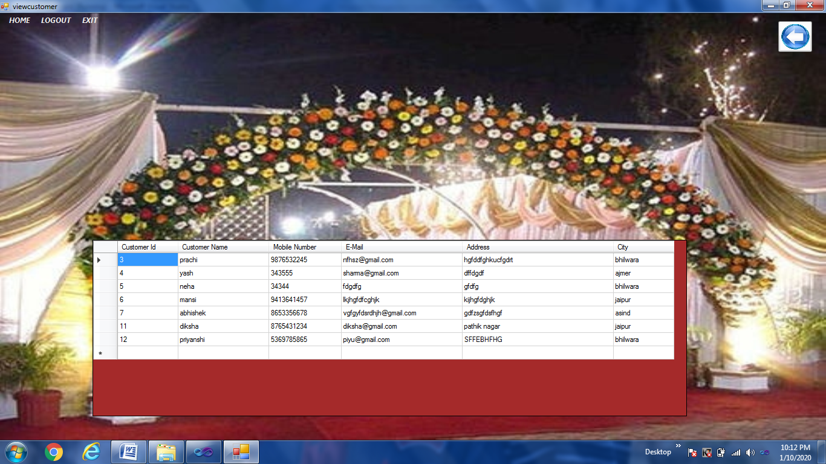

This form provides facility to view details of all customer’s details.

**CODING**

using System;

using System.Collections.Generic;

using System.ComponentModel;

using System.Data;

using System.Drawing;

using System.Linq;

using System.Text;

using System.Windows.Forms;

using System.Data.SqlClient;

namespace eventmanagement

{

public partial class viewcustomer : Form

{

SqlConnection con = new SqlConnection(@"Data Source=.\SQLEXPRESS;AttachDbFilename=C:\event management\eventmanagement\eventmanagement\eventmngmnt.mdf;Integrated Security=True;User Instance=True");

SqlCommand com;

public viewcustomer()

{

InitializeComponent();

}

private void viewcustomer_Load(object sender, EventArgs e)

{

this.customerTableAdapter.Fill(this.eventmngmntDataSet3.customer);

if (con.State == ConnectionState.Closed)

{

con.Open();

}

com = con.CreateCommand();

com.CommandType = CommandType.Text;

com.CommandText = "Select * from customer";

com.ExecuteNonQuery();

DataTable dt = new DataTable();

SqlDataAdapter da = new SqlDataAdapter(com);

da.Fill(dt);

dataGridView1.DataSource = dt;

dataGridView1.Columns[0].HeaderText = "Customer Id";

dataGridView1.Columns[0].Width = 100;

dataGridView1.Columns[1].HeaderText = "Customer Name";

dataGridView1.Columns[1].Width = 150;

dataGridView1.Columns[2].HeaderText = "Mobile Number";

dataGridView1.Columns[2].Width = 120;

dataGridView1.Columns[3].HeaderText = "E-Mail ";

dataGridView1.Columns[3].Width = 200;

dataGridView1.Columns[4].HeaderText = "Address";

dataGridView1.Columns[4].Width = 250;

dataGridView1.Columns[5].HeaderText = "City";

dataGridView1.Columns[5].Width = 100;

}

private void lOGOUTToolStripMenuItem_Click(object sender, EventArgs e)

{

login l = new login();

this.Hide();

l.Show();

}

private void hOMEToolStripMenuItem_Click(object sender, EventArgs e)

{

homepage h = new homepage();

this.Hide();

h.Show();

}

private void eXITToolStripMenuItem_Click(object sender, EventArgs e)

{

Application.Exit();

}

private void hOMEToolStripMenuItem_Click_1(object sender, EventArgs e)

{

homepage h = new homepage();

h.Show();

this.Hide();

}

private void button2_Click(object sender, EventArgs e)

{

customer c = new customer();

c.Show();

this.Hide();

}

}

}

**EVENT FORM:-**

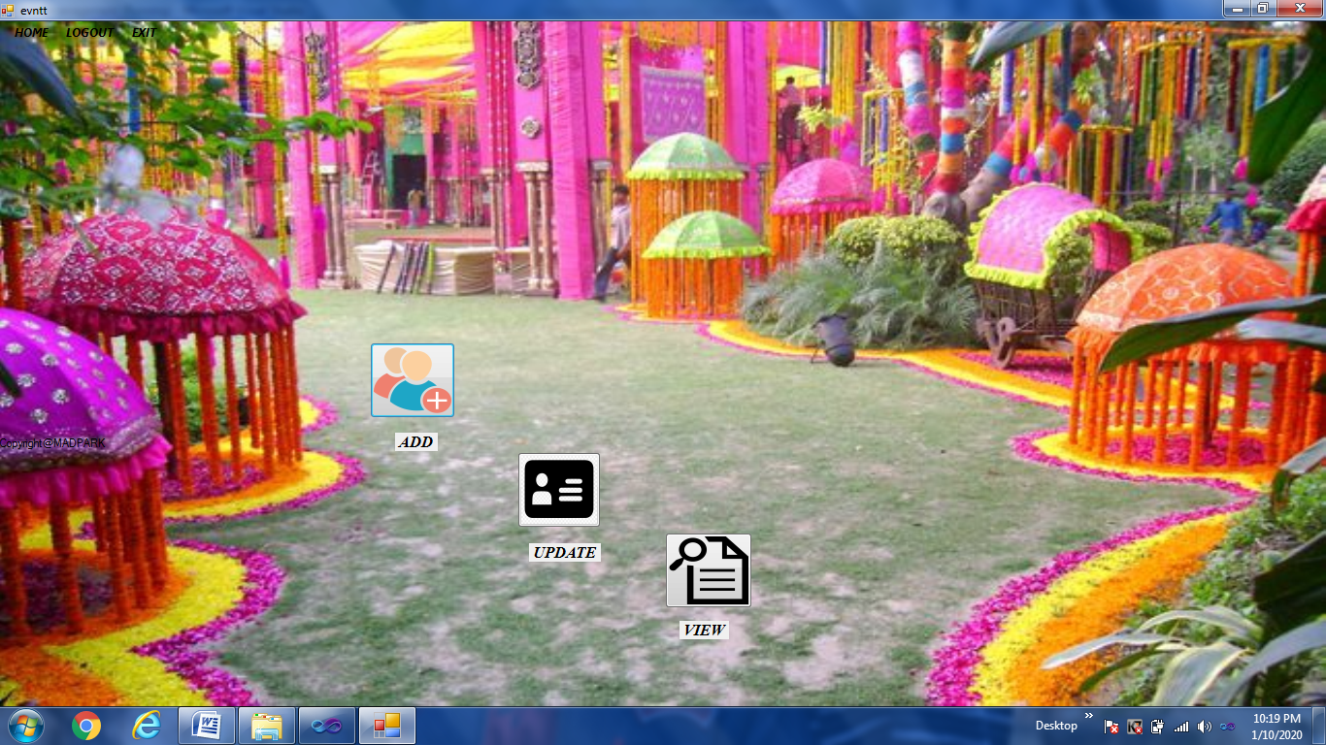

This form adds details about new events when added in company, updating information about existing events and viewing status and details of all events.

**CODING**

using System;

using System.Collections.Generic;

using System.ComponentModel;

using System.Data;

using System.Drawing;

using System.Linq;

using System.Text;

using System.Windows.Forms;

namespace eventmanagement

{

public partial class evntt : Form

{

public evntt()

{

InitializeComponent();

}

private void button1_Click(object sender, EventArgs e)

{

addevent a = new addevent();

this.Hide();

a.Show();

}

private void label1_Click(object sender, EventArgs e)

{

addevent a = new addevent();

this.Hide();

a.Show();

}

private void button3_Click(object sender, EventArgs e)

{

updateevent u = new updateevent();

this.Hide();

u.Show();

}

private void label2_Click(object sender, EventArgs e)

{

updateevent u = new updateevent();

this.Hide();

u.Show();

}

private void button2_Click(object sender, EventArgs e)

{

viewevent v = new viewevent();

this.Hide();

v.Show();

}

private void label3_Click(object sender, EventArgs e)

{

viewevent v = new viewevent();

this.Hide();

v.Show();

}

private void lOGOUTToolStripMenuItem_Click(object sender, EventArgs e)

{

login l = new login();

this.Hide();

l.Show();

}

private void hOMEToolStripMenuItem_Click(object sender, EventArgs e)

{

homepage h = new homepage();

this.Hide();

h.Show();

}

private void eXITToolStripMenuItem_Click(object sender, EventArgs e)

{

Application.Exit();

}

}

}

**NEW EVENT ADD FORM :-**

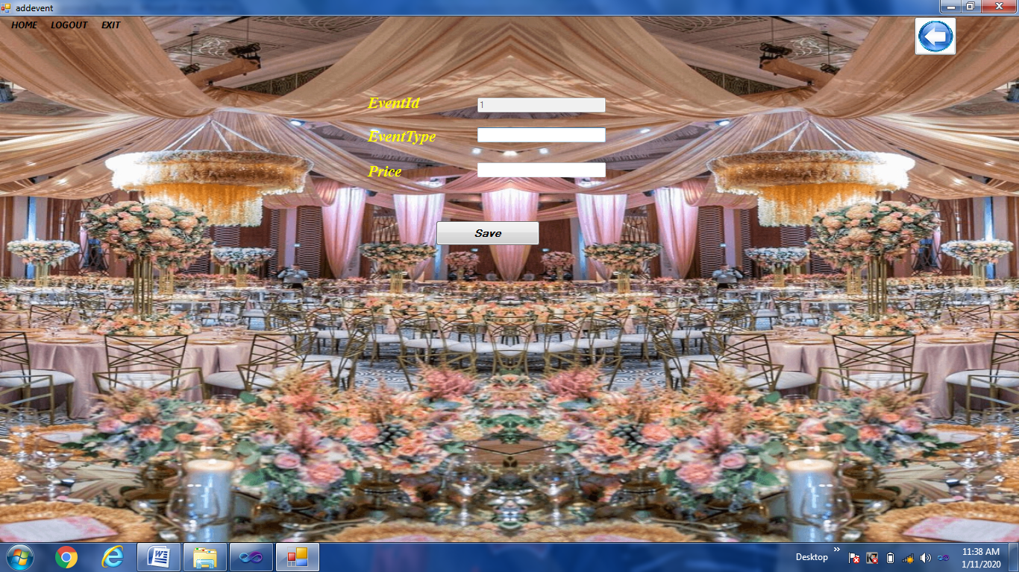

This form provides facility to register and save details of new event.

**CODING**

using System;

using System.Collections.Generic;

using System.ComponentModel;

using System.Data;

using System.Drawing;

using System.Linq;

using System.Text;

using System.Windows.Forms;

using System.Data.SqlClient;

namespace eventmanagement

{

public partial class addevent : Form

{

SqlConnection con = new SqlConnection(@"Data Source=.\SQLEXPRESS;AttachDbFilename=C:\event management\eventmanagement\eventmanagement\eventmngmnt.mdf;Integrated Security=True;User Instance=True");

SqlCommand com;

int i;

public addevent()

{

InitializeComponent();

}

private void addevent_Load(object sender, EventArgs e)

{

string sql = "select count(evntid) from evnt";

if (con.State == ConnectionState.Closed)

{

con.Open();

}

try

{

com = new SqlCommand(sql, con);

SqlDataReader dr;

dr = com.ExecuteReader();

if (dr.Read())

{

i = Convert.ToInt16(dr.GetValue(0)) + 1;

textBox1.Text = i.ToString();

}

dr.Dispose();

}

catch (Exception)

{

MessageBox.Show("error");

}

}

private void button1_Click(object sender, EventArgs e)

{try

{

if (textBox1.Text == "" || textBox2.Text == "" || textBox3.Text == "")

{

MessageBox.Show("Please fill all the details");

textBox2.Focus();

}

else

{

string sql = "insert into evnt(evnttype,price) values(@evnttype,@price)";

com = new SqlCommand(sql, con);

com.CommandType = CommandType.Text;

com.CommandText = sql;

com.Parameters.AddWithValue("@evnttype", textBox2.Text);

com.Parameters.AddWithValue("@price", textBox3.Text);

com.ExecuteNonQuery();

MessageBox.Show("event added successfully");

textBox1.Text = (++i).ToString();

textBox2.Clear();

textBox3.Clear();

textBox2.Focus();

}

}

catch (Exception)

{

MessageBox.Show("error in registration..");

}

}

private void lOGOUTToolStripMenuItem_Click(object sender, EventArgs e)

{

login l = new login();

this.Hide();

l.Show();

}

private void hOMEToolStripMenuItem_Click(object sender, EventArgs e)

{

homepage h = new homepage();

this.Hide();

h.Show();

}

private void eXITToolStripMenuItem_Click(object sender, EventArgs e)

{

Application.Exit();

}

private void button2_Click(object sender, EventArgs e)

{

evntt et = new evntt();

et.Show();

this.Hide();

}

}

}

**EVENT UPDATION FORM:-**

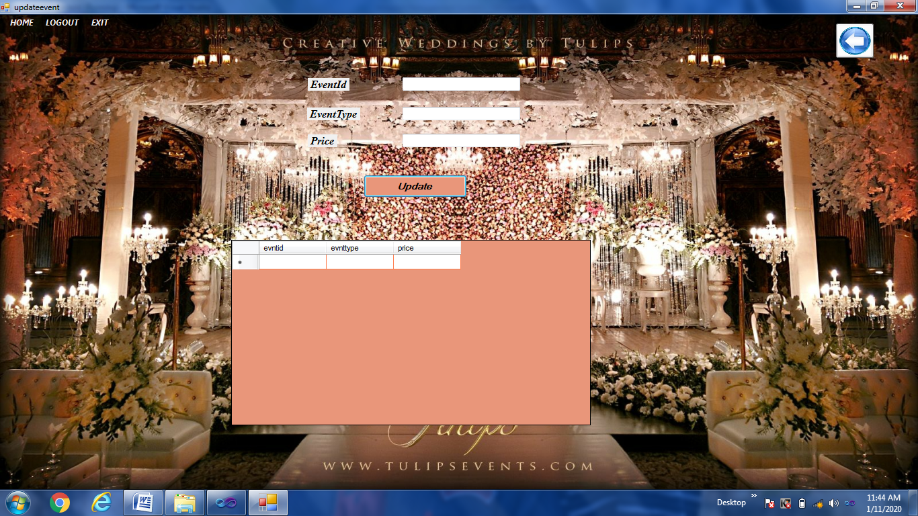

This form allows to update and delete information and status of a event.

**CODING**

using System;

using System.Collections.Generic;

using System.ComponentModel;

using System.Data;

using System.Drawing;

using System.Linq;

using System.Text;

using System.Windows.Forms;

using System.Data.SqlClient;

namespace eventmanagement

{

public partial class updateevent : Form

{

SqlConnection con = new SqlConnection(@"Data Source=.\SQLEXPRESS;AttachDbFilename=C:\event management\eventmanagement\eventmanagement\eventmngmnt.mdf;Integrated Security=True;User Instance=True");

SqlCommand com;

public updateevent()

{

InitializeComponent();

}

public void display()

{

if (con.State == ConnectionState.Closed)

{

con.Open();

}

com = con.CreateCommand();

com.CommandType = CommandType.Text;

com.CommandText = "Select * from evnt";

com.ExecuteNonQuery();

DataTable dt = new DataTable();

SqlDataAdapter da = new SqlDataAdapter(com);

da.Fill(dt);

dataGridView1.DataSource = dt;

con.Close();

}

public void clear_data()

{

textBox1.Clear();

textBox2.Clear();

textBox3.Clear();

}

private void updateevent_Load(object sender, EventArgs e)

{

this.evntTableAdapter.Fill(this.eventmngmntDataSet2.evnt);

display();

}

private void button1_Click(object sender, EventArgs e)

{

if (con.State == ConnectionState.Closed)

{

con.Open();

}

string sql = "update evnt set evnttype=@evnttype,price=@price where evntid=" + Convert.ToInt16(textBox1.Text);

com = new SqlCommand(sql, con);

com.CommandType = CommandType.Text;

com.CommandText = sql;

com.Parameters.AddWithValue("@evnttype", textBox3.Text);

com.Parameters.AddWithValue("@price", textBox2.Text);

com.ExecuteNonQuery();

MessageBox.Show("event updated successfully");

display();

}

private void dataGridView1_CellClick_1(object sender, DataGridViewCellEventArgs e)

{

if (e.RowIndex >= 0)

{

DataGridViewRow r = this.dataGridView1.Rows[e.RowIndex];

textBox1.Text = r.Cells[0].Value.ToString();

textBox3.Text = r.Cells[1].Value.ToString();

textBox2.Text = r.Cells[2].Value.ToString();

}

}

private void lOGOUTToolStripMenuItem_Click(object sender, EventArgs e)

{

login l = new login();

this.Hide();

l.Show();

}

private void hOMEToolStripMenuItem_Click(object sender, EventArgs e)

{

homepage h = new homepage();

this.Hide();

h.Show();

}

private void eXITToolStripMenuItem_Click(object sender, EventArgs e)

{

Application.Exit();

}

private void button2_Click(object sender, EventArgs e)

{

evntt et = new evntt();

et.Show();

this.Hide();

}

}

}

**EVENT DETAILS FORM:-**

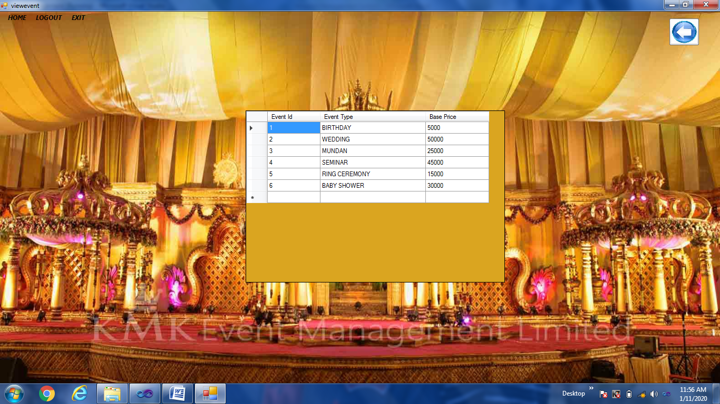

This form allows to view information of all events in company.

**CODING**

using System;

using System.Collections.Generic;

using System.ComponentModel;

using System.Data;

using System.Drawing;

using System.Linq;

using System.Text;

using System.Windows.Forms;

using System.Data.SqlClient;

namespace eventmanagement

{

public partial class viewevent : Form

{

SqlConnection con = new SqlConnection(@"Data Source=.\SQLEXPRESS;AttachDbFilename=C:\event management\eventmanagement\eventmanagement\eventmngmnt.mdf;Integrated Security=True;User Instance=True");

SqlCommand com;

public viewevent()

{

InitializeComponent();

}

private void viewevent_Load(object sender, EventArgs e)

{

// TODO: This line of code loads data into the 'eventmngmntDataSet4.evnt' table. You can move, or remove it, as needed.

this.evntTableAdapter.Fill(this.eventmngmntDataSet4.evnt);

if (con.State == ConnectionState.Closed)

{

con.Open();

}

com = con.CreateCommand();

com.CommandType = CommandType.Text;

com.CommandText = "Select * from evnt";

com.ExecuteNonQuery();

DataTable dt = new DataTable();

SqlDataAdapter da = new SqlDataAdapter(com);

da.Fill(dt);

dataGridView1.DataSource = dt;

dataGridView1.Columns[0].HeaderText = "Event Id";

dataGridView1.Columns[0].Width = 100;

dataGridView1.Columns[1].HeaderText = "Event Type";

dataGridView1.Columns[1].Width = 200;

dataGridView1.Columns[2].HeaderText = "Base Price";

dataGridView1.Columns[2].Width = 120;

}

private void lOGOUTToolStripMenuItem_Click(object sender, EventArgs e)

{

login l = new login();

this.Hide();

l.Show();

}

private void eXITToolStripMenuItem_Click(object sender, EventArgs e)

{

Application.Exit();

}

private void hOMEToolStripMenuItem_Click(object sender, EventArgs e)

{

homepage h = new homepage();

this.Hide();

h.Show();

}

private void button2_Click(object sender, EventArgs e)

{

evntt et = new evntt();

et.Show();

this.Hide();

}

}

}

**BOOKING FORM:-**

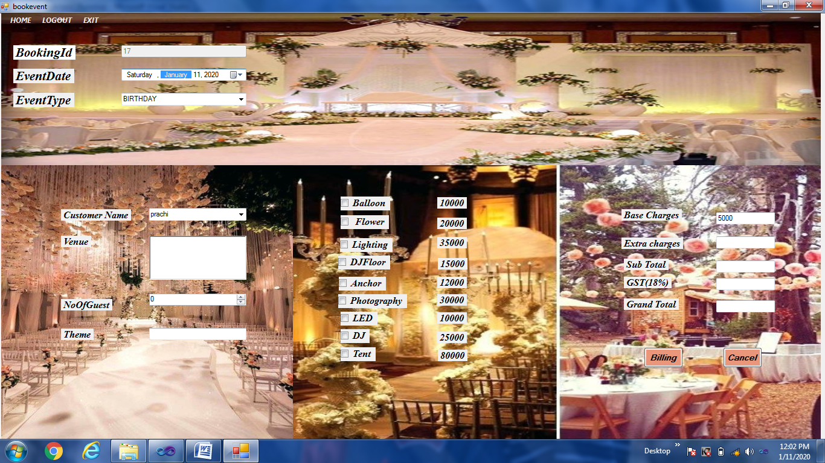

This form provides the facility to book new events and bill information.

**CODING**

using System;

using System.Collections.Generic;

using System.ComponentModel;

using System.Data;

using System.Drawing;

using System.Linq;

using System.Text;

using System.Windows.Forms;

using System.Data.SqlClient;

namespace eventmanagement

{

public partial class bookevent : Form

{

SqlConnection con = new SqlConnection(@"Data Source=.\SQLEXPRESS;AttachDbFilename=C:\event management\eventmanagement\eventmanagement\eventmngmnt.mdf;Integrated Security=True;User Instance=True");

SqlCommand com;

int i;

public static int b;

public static string c;

public bookevent()

{

InitializeComponent();

}

private void hOMEToolStripMenuItem_Click(object sender, EventArgs e)

{

homepage h = new homepage();

this.Hide();

h.Show();

}

private void bookevent_Load(object sender, EventArgs e)

{

this.customerTableAdapter.Fill(this.eventmngmntDataSet1.customer);

this.evntTableAdapter.Fill(this.eventmngmntDataSet6.evnt);

string sql = "select count(bid) from booking";

if (con.State == ConnectionState.Closed)

{

con.Open();

}

try

{

com = new SqlCommand(sql, con);

SqlDataReader dr;

dr = com.ExecuteReader();

if (dr.Read())

{

i = Convert.ToInt16(dr.GetValue(0)) + 1;

txtbid.Text = i.ToString();

}

dr.Dispose();

}

catch (Exception)

{

MessageBox.Show("error");

}

SqlDataAdapter da = new SqlDataAdapter("select evnttype from evnt", con);

DataSet ds = new DataSet();

da.Fill(ds);

foreach (DataRow dr in ds.Tables[0].Rows)

{

cbevnttype.Items.Add(dr[0].ToString());

}

SqlDataAdapter da1 = new SqlDataAdapter("select cname from customer", con);

DataSet ds1 = new DataSet();

da1.Fill(ds1);

foreach (DataRow dr in ds1.Tables[0].Rows)

{

cbcname.Items.Add(dr[0].ToString());

}

}

private void lOGOUTToolStripMenuItem_Click(object sender, EventArgs e)

{

login l = new login();

this.Hide();

l.Show();

}

private void eXITToolStripMenuItem_Click(object sender, EventArgs e)

{

Application.Exit();

}

private void cbevnttype_TextChanged(object sender, EventArgs e)

{

if (con.State == ConnectionState.Closed)

{

con.Open();

}

com = new SqlCommand("select price from evnt where evnttype= '"+cbevnttype.Text+"'", con);

SqlDataReader dr;

dr = com.ExecuteReader();

if (dr.Read())

{

txtbasecharge.Text = dr.GetValue(0).ToString();

}

dr.Dispose();

}

private void txtextracharge_Click(object sender, EventArgs e)

{

long i=0;

if (chkballon.Checked == true)

{ i += Convert.ToInt64(label8.Text);

}

if (chkflower.Checked == true)

{ i += Convert.ToInt64(label10.Text);

}

if (chklighting.Checked == true)

{ i += Convert.ToInt64(label9.Text);

}

if (chkdjfloor.Checked == true)

{

i += Convert.ToInt64(label11.Text);

}

if (chkanchor.Checked == true)

{

i += Convert.ToInt64(label12.Text);

}

if (chkphotography.Checked == true)

{

i += Convert.ToInt64(label13.Text);

}

if (chkled.Checked == true)

{

i += Convert.ToInt64(label14.Text);

}

if (chkdj.Checked == true)

{

i += Convert.ToInt64(label15.Text);

}

if (chktent.Checked == true)

{

i += Convert.ToInt64(label16.Text);

}

txtextracharge.Text = i.ToString();

double u; u=(Convert.ToDouble(txtbasecharge.Text))+(Convert.ToDouble(txtextracharge.Text));

txtsubtotal.Text = u.ToString();

double g = (u * 18) / 100;

txtgst.Text = g.ToString();

txttotal.Text= (u + g).ToString();

}

private void button3_Click(object sender, EventArgs e)

{

try

{

if (txtbid.Text == "" || cbevnttype.Text == "" || cbcname.Text == "" || richTextBox1.Text == "" || txttheme.Text == "" )

{

MessageBox.Show("Please fill all the details");

}

else

{

string sql = "insert into booking values(@bid,@edate,@etype,@venue,@noofguest,@theme,@gst,@subtotal,@baseprice,@extracharge,@cname,@grandtotal)";

com = new SqlCommand(sql, con);

com.CommandType = CommandType.Text;

com.CommandText = sql;

com.Parameters.AddWithValue("@bid", i);

com.Parameters.AddWithValue("@edate",dateTimePicker1.Value.Date.ToShortDateString());

com.Parameters.AddWithValue("@etype", cbevnttype.Text);

com.Parameters.AddWithValue("@venue", richTextBox1.Text);

com.Parameters.AddWithValue("@noofguest", numericUpDown1.Value);

com.Parameters.AddWithValue("@theme", txttheme.Text);

com.Parameters.AddWithValue("@gst", txtgst.Text);

com.Parameters.AddWithValue("@subtotal",txtsubtotal.Text);

com.Parameters.AddWithValue("@baseprice",txtbasecharge.Text);

com.Parameters.AddWithValue("@extracharge",txtextracharge.Text );

com.Parameters.AddWithValue("@cname",cbcname.Text );

com.Parameters.AddWithValue("@grandtotal",txttotal.Text);

com.ExecuteNonQuery();

MessageBox.Show("Bill Added Successfully");

b = Convert.ToInt16(txtbid.Text);

c=cbcname.Text;

Form1 f = new Form1();

f.Show();

this.Hide();

}

}

catch (Exception)

{

MessageBox.Show("error in registration");

}

}

private void dateTimePicker1_ValueChanged(object sender, EventArgs e)

{

string d = dateTimePicker1.Value.ToShortDateString();

string sql = "select bid from booking where edate='" + d + "'";

com = new SqlCommand(sql, con);

SqlDataReader dr;

dr = com.ExecuteReader();

if (dr.HasRows)

{

MessageBox.Show("date has already booked");

txtbid.Enabled = false;

txtbasecharge.Enabled = false;

txtextracharge.Enabled = false;

txtgst.Enabled = false;

txtsubtotal.Enabled = false;

txttheme.Enabled = false;

txttotal.Enabled = false;

cbcname.Enabled = false;

cbcname.Enabled = false;

richTextBox1.Enabled = false;

numericUpDown1.Enabled = false;

}

else

{

txtbid.Enabled = true;

txtbasecharge.Enabled = true;

txtextracharge.Enabled = true;

txtgst.Enabled = true;

txtsubtotal.Enabled = true;

txttheme.Enabled = true;

txttotal.Enabled = true;

cbcname.Enabled = true;

cbcname.Enabled = true;

richTextBox1.Enabled = true;

numericUpDown1.Enabled = true;

}

dr.Dispose();

}

}

}

**SCHEDULE OF EVENT FORM:-**

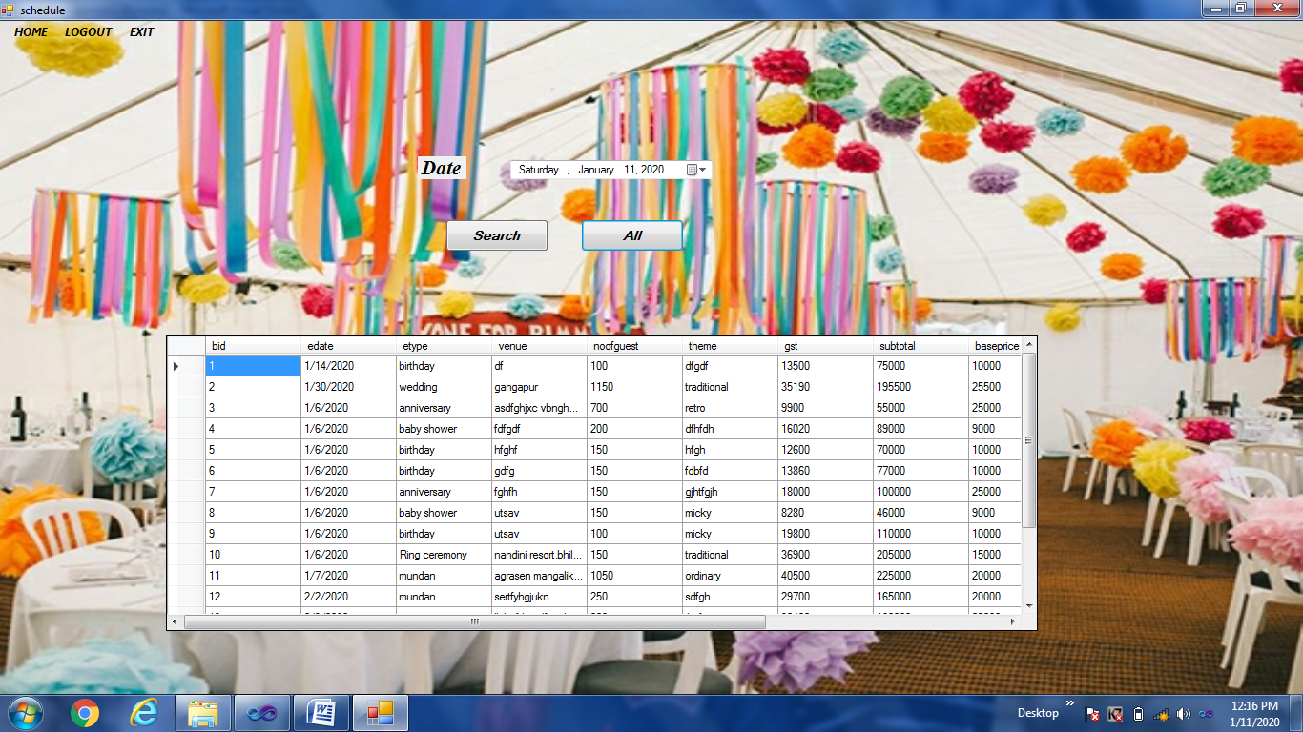

This form saves all the details of event going on.

**CODING**

using System;

using System.Collections.Generic;

using System.ComponentModel;

using System.Data;

using System.Drawing;

using System.Linq;

using System.Text;

using System.Windows.Forms;

using System.Data.SqlClient;

namespace eventmanagement

{

public partial class schedule : Form

{

SqlConnection con = new SqlConnection(@"Data Source=.\SQLEXPRESS;AttachDbFilename=C:\event management\eventmanagement\eventmanagement\eventmngmnt.mdf;Integrated Security=True;User Instance=True");

SqlCommand com;

public schedule()

{

InitializeComponent();

}

private void lOGOUTToolStripMenuItem_Click(object sender, EventArgs e)

{

login l = new login();

this.Hide();

l.Show();

}

private void hOMEToolStripMenuItem_Click(object sender, EventArgs e)

{

homepage h = new homepage();

this.Hide();

h.Show();

}

private void eXITToolStripMenuItem_Click(object sender, EventArgs e)

{

Application.Exit();

}

private void button1_Click(object sender, EventArgs e)

{

if (con.State == ConnectionState.Closed)

{

con.Open();

}

string d = dateTimePicker1.Value.ToShortDateString();

string sql = "select * from booking where edate='"+d+"'";

com = con.CreateCommand();

com.CommandType = CommandType.Text;

com.CommandText = sql;

com.ExecuteNonQuery();

DataTable dt = new DataTable();

SqlDataAdapter da = new SqlDataAdapter(com);

da.Fill(dt);

dataGridView1.DataSource = dt;

}

private void button2_Click(object sender, EventArgs e)

{

if (con.State == ConnectionState.Closed)

{

con.Open();

}

string d = dateTimePicker1.Value.ToShortDateString();

string sql = "select * from booking";

com = con.CreateCommand();

com.CommandType = CommandType.Text;

com.CommandText = sql;

com.ExecuteNonQuery();

DataTable dt = new DataTable();

SqlDataAdapter da = new SqlDataAdapter(com);

da.Fill(dt);

dataGridView1.DataSource = dt;

}

}

}

**BILLING REPORT FORM:-**

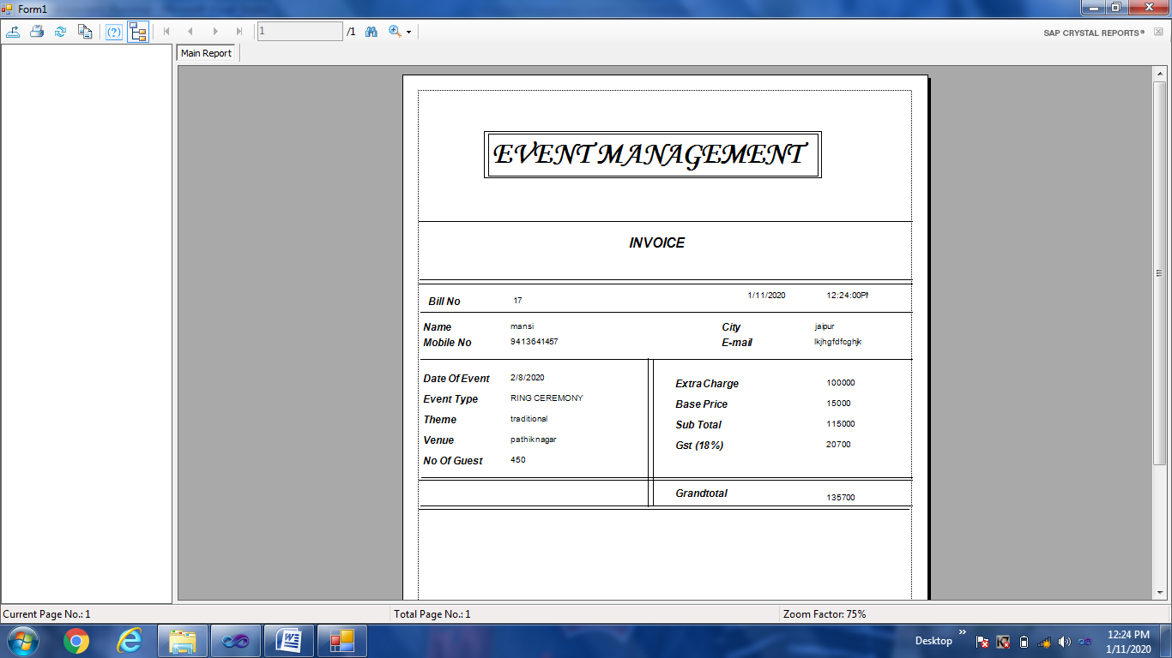

This form is the final bill that is generated by billing form to be printed.

**CODING**

using System;

using System.Collections.Generic;

using System.ComponentModel;

using System.Data;

using System.Drawing;

using System.Linq;

using System.Text;

using System.Windows.Forms;

namespace eventmanagement

{

public partial class Form1 : Form

{

public Form1()

{

InitializeComponent();

}

private void Form1_Load(object sender, EventArgs e)

{

db d = new db();

DataSet ds= d.invoice_pat(bookevent.b);

List<bookinginfo> _l = new List<bookinginfo>();

foreach(DataRow dr in ds.Tables[0].Rows)

{

_l.Add(new bookinginfo

{

bid=Convert.ToInt16(dr[0]),

edate=dr[1].ToString(),

etype=dr[2].ToString(),

venue=dr[3].ToString(),

noofguest=dr[4].ToString(),

theme=dr[5].ToString(),

gst=dr[6].ToString(),

subtotal=dr[7].ToString(),

baseprice=dr[8].ToString(),

extracharge=dr[9].ToString(),

cname=dr[10].ToString(),

grandtotal=dr[11].ToString()

});

}

DataSet ds1 = new DataSet();

ds1 = d.customerinfo(bookevent.c);

foreach (DataRow dr in ds1.Tables[0].Rows)

{

invoice1.SetDataSource(_l);

invoice1.SetParameterValue("pcity", dr[5]);

invoice1.SetParameterValue("pmobile", dr[2]);

invoice1.SetParameterValue("pem", dr[3]);

crystalReportViewer1.ReportSource = invoice1;

}

}

}

}

**SNAPSHOTS OF DATABASE**

**EVENT BOOKING TABLE:-**

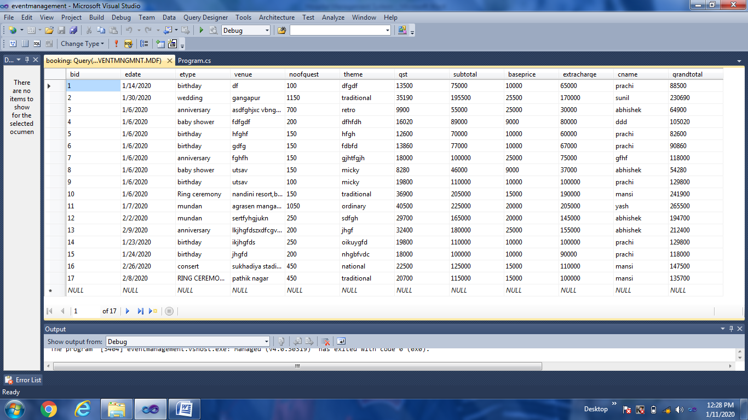

**CUSTOMER TABLE:-**

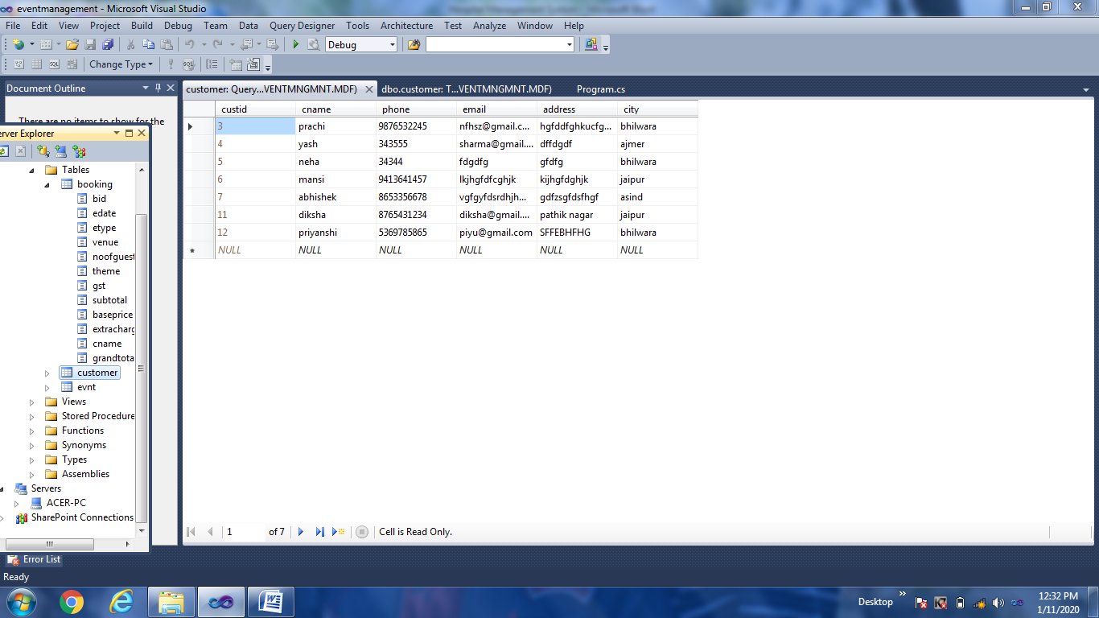

**EVENT TABLE:-**

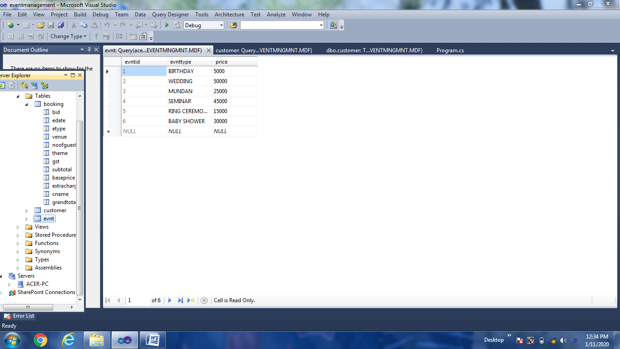

**PROJECT TESTING AND IMPLEMENTATION**

**4.1. SYSTEM TESTING**

Testing is the process of executing a program with the indent of finding any errors. Testing is vital to the success of the system. Without proper testing, hidden errors will surface after sometime of use and perhaps irreversible damage could be done to valuable data. A series of tests like responsiveness, its value, stress and security are performed before the system is ready for user acceptance testing. System testing follows the logical conclusion that is all part of the system are tested and found to be working properly under all kinds of situations, and then the system is achieving its goal of processing the data perfectly according to user rules and requirements. The different types of testing are given below.

* **Unit testing**
* **Validation testing**
* **Output testing**
* **User acceptance testing**

**4.1.1 UNIT TESTING**

It involves the basic testing of a piece of code, the size of which is often undefined in practice. During the unit testing it is tested to know whether that particular unit in the proper manner as expecting, if not appropriate modifications are applied to get proper outputs

**4.1.2 VALIDATION TESTING**

At the conclusion of the black box testing, s/w is completely assembled as a package. Interfacing errors have been uncovered and correct and final series of test, i.e, validation begins. Validation test van is defined with a simple definition that validation succeeds when the software functions in a manner that can be reasonably accepted by the customer. Thus, we have successfully done validation testing.

**4.1.3 OUTPUT TESTING**

After performing the validation testing, next is the output testing of the proposed system. The system cannot be useful if it not produce required output. The output displayed by the system under consideration will be compared with the user needs. Here the output format is considered in 2 ways, screen format and printed format. The o/p format on the screen is found to be correct as the format was defined in the design phase according to user needs. As for the hardcopy the o/p comes according to the specification requested by the user. Here the o/p testing does not result in any correction in the system. Thus we have successfully done output testing.

**4.1.4 USER ACCEPTANCE TESTING**

It is the key for success of any system. The system under consideration is tested for user acceptance by constantly keeping in touch with perspective system at the time of development and making changes whenever required. This is done with regarding to the input screen design and output screen design. Thus we have successfully done user acceptance testing.

**4.2. SYSTEM IMPLEMENTATION**

System implementation is the final phase that is putting the utility into action. Implementation is the state in the project where theoretical design turned into working system. The most crucial stage is achieving a new successful system and giving confidence in new system that it will work efficiently and effectively. The system is implemented only after thorough checking is done and it is found working according to the specifications.

The major implementation procedures are:-

* Test plans
* Training
* Equipment installation
* Conversion

**4.2.1:Test plans**

The implementation of a computer based system requires that the test data can be prepared and the system and its elements be tested in a structured manner.

**4.2.2:Training**

The purpose of training is to ensure that all the personnel who are to be associated with the computer based system possesses necessary knowledge skills.

**4.2.3:Equipment installation**

Equipment vendors can provide specifications for equipment installation. They usually work with projects equipment installation team is planning for adequate space, power and light, and a suitable environment. After a suitable site has been completed, the computer equipment can be installed.

**4.2.4:Conversion**

It is the processes of performing all of the operations that result directly in turnover of the new system to the user. Conversion has two parts:-

1. The creation of a conversion plan at the start of the development phase and the implementation of the plan throughout the development phase.

The creation of a system change over plan at the end of the development phase and the implementation of the plan at the beginning of operation phase.

**USER MANUAL**

Following steps should be taken for the execution of “EVENT MANAGEMENT SYSTEM”

* Insert the Project CD in the CD drive.
* Create a folder “event management” in C drive in your system.
* Copy Project folder to the recently created folder “event management”.
* Run the project by double clicking on project exe file named “eventmanagement”.
* Login using user name =”madpark” and password=”priyanshi”.
* Choose desired option by clicking on the various available menus from the HOME PAGE FORM and use this project.

**CONCLUSION**

Salient Feature of the Union Selection System:-

* Attractive forms are designed.
* Various validation and error check are done at number of places.
* Validation message are given at every step.
* System is fast and reliable.
* Can easily insert, update, and search for customers and events.
* At every insertion and updation, a message box will appear showing the entered values.
* By entering the event’s name and customer’s name, we can search their information .
* By using data grid we can get list of all the event’s , customer’s and booking’s information who registered in the company.

It’s our privilege that the project entitled “Event Management System” is successfully completed and presented by me. This project enhanced our S/W development skills up to a greater extent. This project was completed during short span of time, so it may have some or lack of some facilities but still it is up to level of satisfaction. During the project we conclude that without motivation a single person can’t complete the project.

The project entitled “Event Management System” has developed a lot of confidence in me that we can develop any type of project using Visual Studio 2010.

We would like to thank our all faculty members of college who inspired me and helped directly or indirectly during the completion of this project.

* 1. **LIMITATION OF THIS PROJECT-**

This project include some limitations :–

* Does not consider any financial implications or commitments from the event management.
* Doesn’t provide online services for any users.
* Does not provide details about event current status.

There will be some minor mistakes that is avoided**.**

**(B) WHAT NEW THINGS CAN BE ADDED**

This project has been design to work on a large scale so, according to our analysis the future scope of the project is bright and would have an everlasting effect on the current system.

The Event Management System platform can be made more secure by using the following methods :-

* + - * + Making the project Online
        + Sending copy of bill to customer by e-mail

The Attendance of all the staff members could be taken by matching their fingerprints by using Biometric Attendance Punch Machines. This helps maintaining attendance in a better way than maintaining a daily register. So it helps to increase the security of the system. Sending e-mail of bills makes the procedure paperless and even faster. But here the problem is that the project is offline so we can't implement this process now, it decreases the scope of the platform. Making the project online may solve this problem in future.

**Event’s update through SMS**

In future we can add an SMS query also. i.e. we wil get the updates about events added through the company and booked by the customer. To receive the SMS we need to register with our mobile number in the system.

**The system can be used by different Companies according to their needs.**

**BIBLIOGRAPHY**

* Programming in C# by E Balagurusamy
* [www.google.com](http://www.google.com)
* <http://www.freestudentprojects.com>
* <http://www.tutorialspoint.com>
* [www.youtube.com](http://www.youtube.com)

**SOFT COPY OF PROJECT**